

Internship FSD v0.1

# Revision History

| Date | Version | Description | Author |
| --- | --- | --- | --- |
| 2015-06-29 | 0.1 | First Draft | Madalin Sandu |
|  |  |  |  |
|  |  |  |  |

## 1.1 Header and navigation

**3**

**2**

**1**

1. **Logo**

Logo should be text, clicking on it redirects the user to the homepage

1. **Search**

Click on the search icon expands the suggestions functionality, 2 options:

* 1. Static results display: display a dropdown with dummy text
  2. Dynamic results display: display suggestions from a json file

1. **Login or Register**

Click on it opens the Login/register pop-up. Forms to be created by developer according to the site general design

1. **Navigation**

No special functionality required

1. **Mini-cart and wishlist**

Green icon indicates a hover state, the ocons should be implemented with fonts.

**5**

**4**

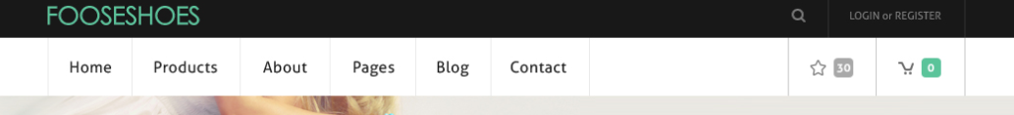

**2**

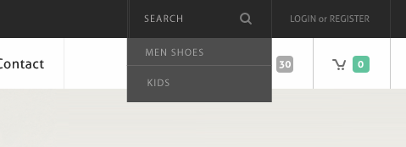

## 1.2 Slider

1. **Slider image**

Each slide should use its own image

1. **Slider text**

Static text including price, title, description and action buttons. Icons should be implemented with fonts.

* 1. Hover state for icons.

1. **Slider controllers**

Maximum of 3 slides

**3**

**2a**

**2**

**1**

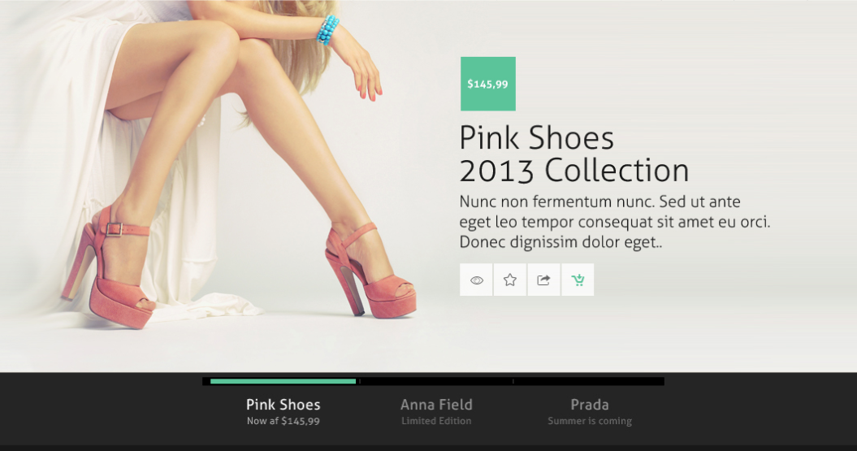

## 1.3 Homepage

1. **Static content**
2. **Show all button**

Hover state required

1. **Product tile**
   1. On sale badge
   2. Out of stock badge
   3. Hover product tile will display action buttons with hover state implemented with font icons
2. **Static content**
   1. Free shipping and testimonials plain text’
   2. Blog news: every 5 seconds new content will be displayed with fade in/out animation

## 

**4b**

**4a**

**4**

**3c**

**3b**

**3a**

**3**

**2**

**1**

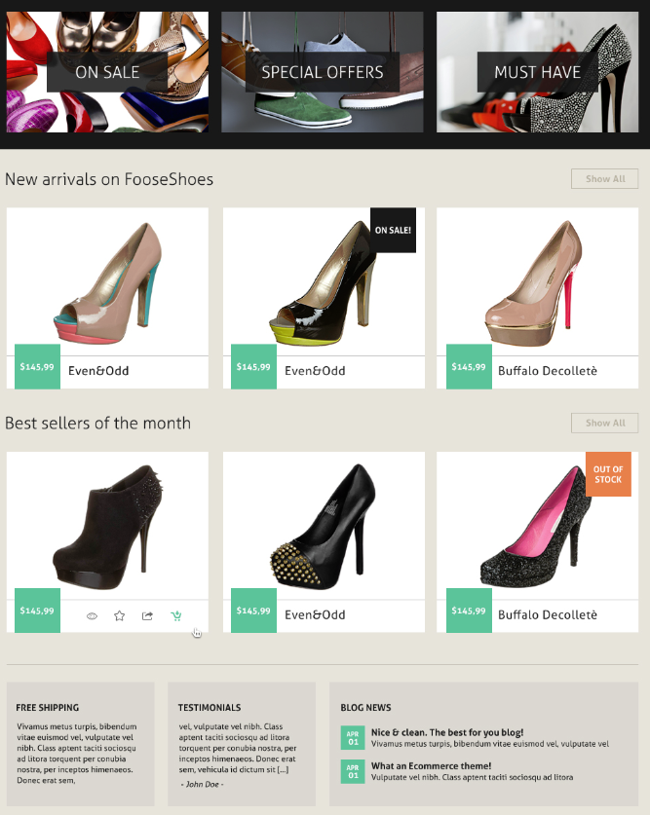

## 1.4 Footer

1. **Static widget**

Static content

1. **Twitter widget**

Once every 5 seconds the content changes

1. **Flickr widget**

Clicking on images will open them in a bigger version overlaying the entire page.

1. **Newsletter**

Email validation required. On submit save the email address in to a json file.

1. **Social buttons**

Static social buttons with hover state

**5**

**4**

**3**

**2**

**1**

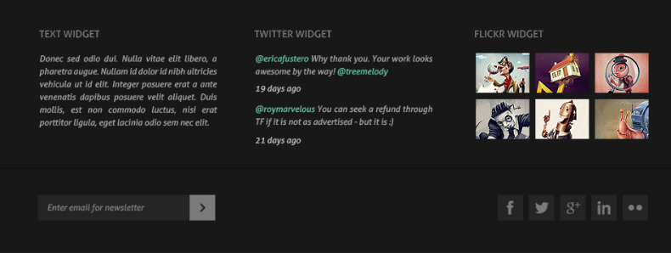

## 2 Product grid

1. **Static top banner**

Background and content

1. **Custom select boxes**
2. **Grid change**

2 options:

1. Grid view: products should be displayed one next to each other
2. List view: one product per line

**3**

**2**

**1**

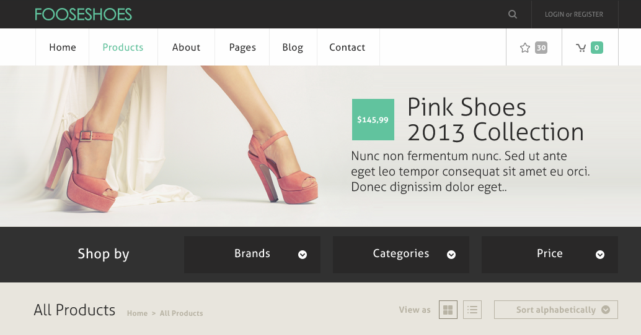

## General specifications

Technologies to be used:

1. HTML5(validation required)
2. CSS3, SASS(gulp compiler or compass)
3. JavaScript/jQuery
4. Responsive:
   1. Homepage 960px for screens that are bigger than 960px, fixed layout
   2. Homepage 768px for screens that are between 768px and 960px, fixed layout
   3. Homepage 320px for screens that are between 320px and 768px, fluid layout.

For the missing sections, the developer should take decisions regarding the layout and how it should look.

1. GIT: the project will be hosted on GIT
2. Photoshop